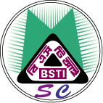 | BANGLADESH STANDARDS AND TESTING INSTITUTION  MANAGEMENT SYSTEMS CERTIFICATION  116/A Tejgaon Industrial Area, Dhaka-1208 | 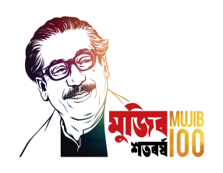  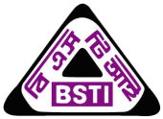  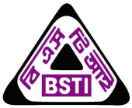  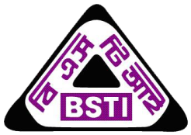

TRAINING SCHEDULE
Duration | Venue | Course Title | Fee per person
18-19 March 2020 | Training Room  Administration Building (No.1), BSTI  116/Ka, Tejgaon Industrial Area, Dhaka-1208 | ISO 22000:2018-Requirements for any Organization and Document Control System | Tk.4,500.00 and 15% VAT  (Course materials, note books, meals, and refreshments are all inclusive)
6-7 April 2020 |  | ISO 9001:2015-Requirements for any Organization and Internal Audit

Contact Details:
Management System Certification Wing  Maan Bhaban  Bangladesh Standards and Testing Institution (BSTI)  116/Ka, Tejgaon Industrial Area  Dhaka-1208, Bangladesh | Mr. Md. Nozir Ahmmod Miah  Deputy Director (Int. Audit/Assessment)  Cell:+880 1712131187  Email: Nozir_bsti@yahoo.com
Ms. Joyshree Das
Deputy Director (Doc. Control)
Cell:+880 1817569572
Email: joyshree_ma@yahoo.com
ICT Cell
Tel:+880 28878181
Email: ictcell.bsti@gmail.com
Note: Download registration form and deposit requisite fees at One Stop service center. Then send your application after filling registration form with money receipt to the contact person through email.

